Syeda Reeha Quasar

14114802719

4C7

Aim

Using concept of function overloading, write function for calculating area of triangle, circle and rectangle.

Experiment - 4

Object Oriented Programming Lab

# **EXPERIMENT – 4**

## **Aim:**

Create a class student which have data members as name, branch, roll no., age, sex and marks in five subjects. Display the name of the student and his percentage who has more than 70%.

## **Source Code:**

#include <iostream>

#include <string>

using namespace std;

class studentRecord{

    private:

        string name;

        string branch;

        int rollNo;

        int age;

        char sex[15];

        float marks;

    public:

        void getDetails();

        void check();

        void showDetails();

        void details();

};

void studentRecord::getDetails(){

    cout << "Enter name" << endl;

    cin >> name;

    cout << "Enter branch" << endl;

    cin >> branch;

    cout << "Enter Roll no. "<< endl;

    cin >> rollNo;

    cout << "Enter age" << endl;

    cin >> age;

    cout << "Enter sexuality" << endl;

    cin >> sex;

    cout << "Enter total marks scored in 5 subjects" << endl;

    cin >> marks;

}

void studentRecord::showDetails(){

    cout << "Name: " << name << endl;

    cout << "Percentage: " <<  (marks/5) << "%" << endl;

}

void studentRecord::check(){

    if (((marks/5)) > 70) {

        showDetails();

    }

}

void studentRecord::details(){

    cout << "name: " << name << ", branch: " << branch << ", roll no.: " << rollNo << ", age: " << age << ", sex: " << sex << ", marks: " << marks << endl;

}

int main(int argc, char const *argv[]){

    int students;

    cout << "Enter the no. of students: ";

    cin >> students;

    studentRecord studentsArr[students];

    for (int i = 0; i < students; ++i) {

        cout << "For student" << i + 1 << " :" << endl;

        studentsArr[i].getDetails();

    }

    cout << "\nYou have entered:" << endl;

    for (int i = 0; i < students; i++) {

        studentsArr[i].details();

    }

    cout << "\n\n\n" << endl;

    cout << "Students having marks greater than 70% are: " << endl;

    for (int i = 0; i < students; i++) {

        studentsArr[i].check();

    }

}

## **Output:**

## 

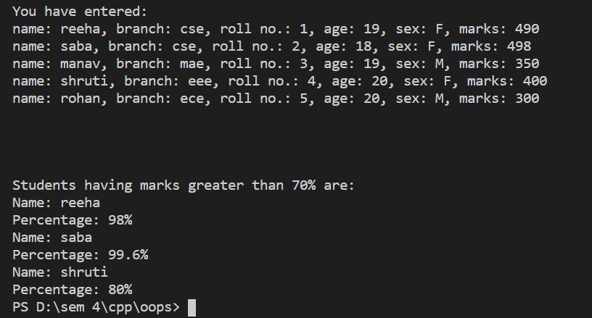

# **Viva Questions**

### 1. What is an abstract class and when do you use it?

Ans.

A class is called an abstract class whose objects can never be created. Such a class exists as a parent for the derived classes. We can make a class abstract by placing a pure virtual function in the class.

### 2. What are destructors in C++?

Ans.

A constructor is automatically called when an object is first created. Similarly when an object is destroyed a function called destructor automatically gets called. A destructor has the same name as the constructor (which is the same as the class name) but is preceded by a tilde.